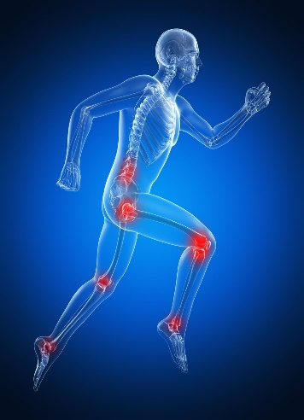
Recovery Sports Therapy
Price List

Initial Injury Assessment 1 hour = £45

Sports Massage Appointment 30 mins = £25
Sports Massage Appointment 1 hour = £35

Rehabilitation Appointment
after initial consultation 30 mins = £20

10% off when introducing someone new

Maundrell BSc (Hons)
Sports Therapist
Graduate Member of the Society of Sports Therapists

Phone: 07952 295364
Email: RecoverySportT@gmail.com

